**Project Design Phase-II**

**Technology Stack - Architecture & Stack**

|  |  |
| --- | --- |
| Date | 02 October 2022 |
| Team ID | PNT2022TMID39226 |
| Project Name | Machine Learning Based Vehicle Performance Analyser |
| Maximum Marks | 4 Marks |

**Technical Architecture:**

The Deliverable shall include the architectural diagram as below and the information as per the table1 & table 2

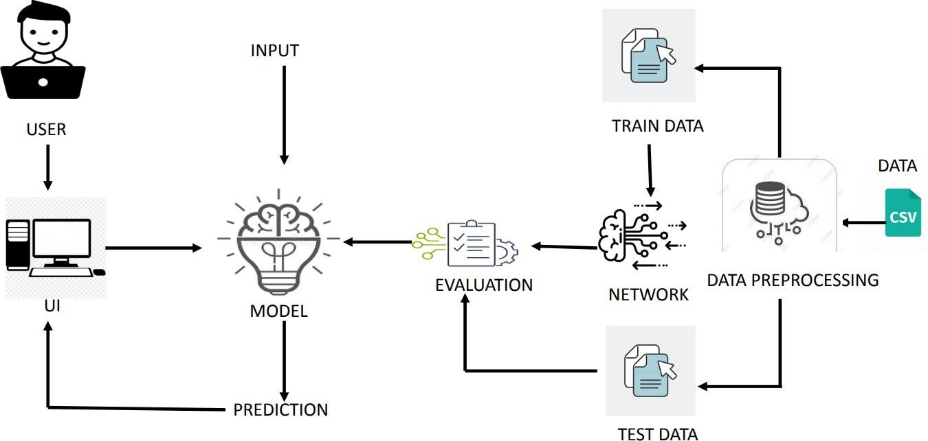

**Table-1: Components & Technologies:**

|  |  |  |  |
| --- | --- | --- | --- |
| **S. No** | **Component** | **Description** | **Technology** |
| 1. | User Interface | How user interacts with application e.g.  Web UI | HTML, CSS, Bootstrap |
| 2. | Application Logic-1 | Logic for a process in the application | Java / Python |
| 3. | Application Logic-2 | Logic for a process in the application | IBM Watson STT service |
| 4. | Application Logic-3 | Logic for a process in the application | IBM Watson Assistant |
| 5. | Cloud Database | Database Service on Cloud | IBM DB2, IBM Cloud ant etc. |
| 6. | File Storage | File storage requirements | IBM Block Storage or  Other Storage Service or  Local File system |
| 7. | Machine Learning Model | To predict the Vehicle performance | IBM Watson Service |
| 8. | Infrastructure (Server / Cloud) | Application Deployment on Local System / Cloud  Local Server Configuration:  Cloud Server Configuration : | Local, Cloud Foundry, Kubernetes, etc. |

**Table-2: Application Characteristics:**

|  |  |  |  |
| --- | --- | --- | --- |
| **S .No** | **Characteristics** | **Description** | **Technology** |
| 1. | Open-Source Frameworks | Bootstrap, Flask, numpy, pandas | Html, CSS, Python |
| 2. | Scalable Architecture | 3-tier architecture | Html, CSS, Python |
| 3. | Availability | Single server | IBM cloud server |
| 4. | Performance | More Accurate Prediction Cookie Free Domain | Python |